**Team 10: Project M**

Dajiba Patil, Abhijeet Chavan, Myles Lefkovitz, Daniel Reeves

[dpatil32@gatech.edu](mailto:dpatil32@gatech.edu), [achavan8@gatech.edu](mailto:achavan8@gatech.edu), [mlefkovitz@gatech.edu](mailto:mlefkovitz@gatech.edu) [danielreeves@gatech.edu](mailto:danielreeves@gatech.edu)

**Abstract.** During the task of shopping, users waste both time and energy due to inefficiencies in their methods and the available help they have at their disposal. Team 10’s objective is to make shopping more pleasant and efficient by empowering the user with an interface to shop efficiently. In this assignment we have followed the entire life cycle of user centric design to come up with interface designs that will ease the experience of shopping for users. We have carried out surveys, interviews with store managers and interviews with professional shoppers as part of the three needfinding exercises to come up with paper and wireframe prototypes. We have then evaluated these prototypes using qualitative and predictive evaluation. Though most of the user needs were satisfied, our next step would be to take the prototype to higher fidelity while focusing on the store owners concerns.

# Introduction

Shopping at stores for many customers is inefficient and challenging, especially when the customer is in hurry. Customers tend to spend too much time searching for items and shopping them outside of the shortest path. The challenges for shoppers do not start at the store, but can start before the store is entered. The goal of this team project is to design an interface that can help users perform many tasks related to shopping, from creating a shopping list to helping the user shop for items on their list more efficiently. This exercise is continuation of the project done by Dajiba Patil for his M assignments. However, in this project we expand the scope to include professional shoppers and investigate the problem of stores not sharing critical information such as store location, layout, product placement in aisle and bin etc. and how best to mitigate those scenarios.

This project plans and executes need-finding exercises related to gathering data about shopper activity, both from the shopper’s perspective and the store owner’s perspective. Need-finding in this area incorporates a wide range of data-gathering using techniques learned in class. We discuss the results of customer surveys, interviews with professional shoppers, and interviews with store owners. The goal of each of these need-finding methods was to understand the needs of the users and ultimately brainstorm and plan out prototypes for improving the task of shopping for users based on the requirements gathered from need-finding and research.

The prototypes leverage technology for improving the task of shopping, either in the form of a smartphone application or in the form of physical units placed inside the store or units attached to the shopping carts. The pros and cons of each prototype was analyzed based on the data inventory and what the users prefer based on the research data gathered from our need-finding exercises. From the initial need-finding to the final prototype analysis, the goal of improving the overall task of shopping aims to bring forth positive changes to the users of this particular task.

# Needfinding Planning

We have identified 3 types of users for this tool: Store customers (regular people who visit stores to purchase goods for themselves), professional shoppers (e.g. Instacart or Shipt shoppers) who shop on behalf of their customers, and finally the store owners. Store customers and professional shoppers are customers who would use the interface created in the first design iteration for this task. Store owners are a different type of user with different needs. Buy-in from store owners will be needed for this application to succeed. Store owners will play a part in ensuring that the interface can remain updated with consistent information about store products.

With these three user groups, we are limited in the types of needfinding analyses we can perform. Since no similar interface exists today, we cannot perform think-aloud sessions, or analyze data logs or product reviews. The only available options for identifying the needs of store customers are naturalistic observation, participant observation, surveys, and interviews. The only available option for identify the needs of store owners are surveys and interviews (we can’t observe them, since they usually act behind the scenes, and we don’t know enough about them to act as participants).

The initial design iteration performed during the M assignments utilized surveys, participant observation, and naturalistic observation of store customers. We thought we could elaborate on some of the findings for store customers via an additional survey. For professional shoppers and store managers, we didn’t have a way to locate and contact enough of these users to perform naturalistic observation or surveys, but we were confident that we could perform interviews with them to understand their needs.

## Needfinding Plan 1 - Surveys for Store Customers

Store customers were the target audience for needfinding in the first interface design iteration. We will use these surveys to ask more targeted questions that will drive the design of the interface.

The goal of this survey will be to better understand shoppers’ current practices when shopping in stores. The questions asked will reveal how frequently they carry their smartphones (key to being able to use an app-based interface), how often they look for new items, how much time they spend looking for those items, how frequently they ask for help, and how helpful they find the help. We will also ask shoppers what they think will help improve their shopping experience. Please refer to **Appendix A** for detailed survey questions.

**Data Inventory Items**

In the first iteration of this interface design, we identified who the users are (shoppers), where they are (in stores), the context of their task (busy focusing on finding their items and navigating the store), their goals (buying the items on their shopping list), and their task (buying items).

We will use the surveys below to identify the remaining data inventory items (the user’s needs and their subtasks) as mentioned above.

**Biases**

With surveys, we may encounter a number of potential biases: confirmation bias, observation bias, voluntary response bias, and recall bias all present potential issues.

Confirmation bias poses a risk at the survey review phase. We will limit the impact of confirmation bias by collecting as much empirical data as possible from the respondents and leaving questions open-ended, inviting them to provide information that’s not aligned with our questions. Once in the data-review phase, we will specifically seek out information that contradicts our pre-existing notions.

Observation bias poses a risk at the survey design phase. We may design a survey that aligns too closely with our specific beliefs about shopping. We will limit this impact by scripting the survey as neutrally as possible.

Voluntary response bias poses a risk to our survey, as users more excited about shopping (in either direction) are more likely to respond. We will limit this impact by avoiding showing questions to users until they’ve begun the survey.

Recall bias poses a risk to our survey at the response phase. Respondents may not have shopped recently (or may not have shopped for new items recently). We can limit this impact by inviting respondents to consider their recent previous experience shopping.

## Needfinding Plan 2 - Interviews with Professional Shoppers

Professional shoppers are a new target audience that we speculate could find good use from an interface like the one designed in the previous iteration. We’ll conduct interviews with professional shoppers to learn more about the tools available to them, their inputs, and their needs.

**Data Inventory Items**

With this new user group we will need to identify each of the data inventory items. We suspect we have an understanding of who the users are (professional shoppers), where they are (in stores), the context of their task (busy focusing on finding their items and navigating the store), their goals (buying the items on behalf of their users’ shopping list), and their task (buying items).

We will use the interview below to confirm our understanding and identify the remaining data inventory items (the user’s needs and their subtasks).

**Biases**

With interviews, we may encounter a number of potential biases: confirmation bias, observation bias, and social desirability bias all present potential issues.

We can limit the impact of confirmation bias by collecting as much empirical data as possible from the respondents and leaving questions open-ended, inviting them to provide information that’s not aligned with our understanding. Once in the data-review phase, our team will specifically seek out information that contradicts our pre-existing notions.

Observation bias poses a risk at the script design phase. We may design an action or question that aligns too closely with our specific beliefs about the experiences of professional shopper. We will limit this impact by scripting the questions as neutrally as possible.

Social desirability bias poses a risk during the interview. We will limit this impact by conducting interviews over the phone (not revealing the interviewer’s face) and making sure to ask questions exactly as scripted, with no sound guiding the user to a specific answer.

**Planned interview script:**

Thank you for taking the time to meet with me today. I’d like to discuss your role as a professional shopper.

1. Can you briefly walk through a recent typical professional shopping experience (maybe walk through a day or a shift)?
2. When shopping for customers instead of shopping for yourself, what differs about the experience?
3. What is your main focus when shopping for customers?
4. How many customers are you typically shopping for at a time?
5. What tools does your shopping company (Instacart) provide you with?
6. Is there anything you can think of that could improve your shopping experience?
7. What do you do if a particular item is not available in store?
8. How frequently do you need to ask for help in locating an item?

## Needfinding Plan 3 - Interviews with Store Owners/Managers

Store owners/Managers are an important users whose needs were not evaluated in the first iteration of the design of this interface and as such, it's very important to take their consent in terms sharing some key business-related information such as store locations, store size, store layout and product placement in aisle and bins. This information is crucial at times as it might impact the business strategy in terms of sales, forecasts and competition. Furthermore, protecting the above information from its competitor also forms one of the requirement for this interface. To unfold the above mystery, we are planning to interview the Store Managers as part of our need finding exercise.

**Data Inventory Items**

With this new user group we will need to identify each of the data inventory items. We suspect we have an understanding of who the users are (store owners/managers), where they are (in stores), the context of their task (creating a dynamic environment that best supports their customers), their goals (enrich the experience of their customers in order to maximize profit)..

As a secondary user for our tool, we understand that these users have tasks, but we assume that their tasks are unrelated to the tasks of the customers.

We will use the interview below to confirm our understanding and identify the remaining data inventory items (the user’s needs and their subtasks).

**Planned interview script:**

Thank you for taking the time to meet with me today. I’d like to discuss your role as a store owner (or manager).

1. Customers often visit your store looking for items they haven’t purchased before, either as first time customers or as repeat customers buying a new item for the first time. As a store owner, do you think your customers have any issues finding products within your stores?
2. What steps can customers take to seek help finding the items on their shopping lists?
3. How many dedicated staff do you have to help customers find items?
4. How many hours do you estimate your staff dedicates to helping customers find the items they’re shopping for?
5. How interested are you in collaborating with third parties to help your customers find items within your store?
6. Would you be willing to share the layout of your store and each item’s bay location with third parties?

**Biases**

With interviews, we may encounter a number of potential biases: confirmation bias, observation bias, and social desirability bias all present potential issues.

We can limit the impact of confirmation bias by collecting as much empirical data as possible from the respondents and leaving questions open-ended, inviting them to provide information that’s not aligned with our understanding. Once in the data-review phase, our team will specifically seek out information that contradicts our pre-existing notions.

Observation bias poses a risk at the script design phase. We may design an action or question that aligns too closely with our specific beliefs about the experiences of store owners. We will limit this impact by scripting the questions as neutrally as possible.

Social desirability bias poses a risk during the interview. We will limit this impact by conducting interviews over the phone (not revealing the interviewer’s face) and making sure to ask questions exactly as scripted, with no sounds guiding the user to a specific answer.

# Needfinding Execution

## Needfinding Plan 1 - Surveys for Store Customers

**Survey Results and Observations**

In total, our team received fifty responses to the sixteen survey questions. A few of the **raw results** gleaned from this data include the following observations:

1. When purchasing new items, most respondents (31/48) claim they spend 10 minutes or more searching for these items within stores.
2. The average shopper surveyed was satisfied with their current shopping experience. 5/50 shoppers were dissatisfied, 15/50 were neutral in satisfaction, 30/50 either agreed or strongly agreed that they were satisfied.
3. Many shoppers thought that an electronic product locator (36/50), mapping tools (26/50), or a shopping list (24/50) would benefit their shopping experiences.
4. 44/50 respondents claimed they had a smartphone with while they shop ‘very frequently’.
5. Most respondents (44/50) do not utilize existing shopping cart programs such as Kroger’s clicklist, nor do they (42/50) utilize existing shopping cart services such as Instacart.
6. Of the users that have utilized these types of services, 6/8 of the respondents used them due to a busy schedule.
7. Shopping lists were utilized by 33/50 of the respondents ‘frequently’ or ‘very frequently’.
8. Shoppers create their own list an average 55% percent of the time (with others creating a list for them 45% of the time).
9. 36/50 users agree or strongly agree that planning the path to collect each item on list is helpful while shopping.
10. 36/50 users agree or strongly agree that they are satisfied with the existing help they receive in stores while on their shopping trips.

**Survey Results Analysis**

The **takeaway** from this survey is that many of the respondents spent more time searching for an item they did not know the location of while on their shopping trip. The results of the shopping experience question for these users show there is possible improvement in this area, as most noted an “average experience” when shopping. Improvements in this area such as the store shopping list and electronic product locator showed considerable interest from those surveyed. As most of the respondents carry their personal smartphone with them while shopping, the possibility to improve the experience with this task utilizing a smartphone is one opportunity that is presented.

One interesting fact that came out of this survey is that most of the respondents have not utilized an existing shopping cart service such as Kroger’s Clicklist or Instacart. One user noted that this was due to lack of promotions of these services by the stores themselves, poor user guidance of these services, and general awareness of these existing programs was low. The small amount of users that did utilize these services, however, utilized them due to a busy schedule.

Overall, it appears that the results of this survey show that there is an opportunity to improve the experience of shopping for users through applications of technology in the areas where it is most needed. The users’ goals in the data inventory can be met through this application and the subtasks discovered by the surveys (path taken while shopping, item aisle searching, etc) are disclosed and improved where applicable.

**Data Inventory Items collected post Survey**

As mentioned earlier during the first iteration of the interface design, we identified who the users are, especially these are the folks who go beyond the gender boundaries and span number of users from working professionals to housewives, adults to seniors, folks who want to shop leisurely vs those who are in hurry. Further to this, some of these users are very meticulous or a detail-oriented (experts) who like to compare different items based on price, brands, discounts, coupons etc. whereas the others are casual shoppers (novice). **Where** are they? They can be found in stores shopping items or some of them are at work or home busy preparing their shopping list. The **context** in which these users will use the interface will be while shopping and or navigating the stores. Another dimension to this is, the users can prepare the shopping list anywhere, such as while walking, jogging or while in car via voice enabled features. The main **goal** for these users is buying items on their shopping list which leads to number of **tasks** such as shopping items based on the shopping list, buy the best possible item based on number of criteria, shop within the allocated time, pay for items while shopping etc. These tasks further lead to number of **sub tasks** such as prepare shopping list, select the best possible store path based on available time, scan and pay for the item once the same is picked from the bin, compare items from number of alternatives etc. In order to execute these tasks, the users **need** a medium such as a cellphone, tablet and or pair of glasses that can display shopping list and directions to find and purchase items etc.

In addition to the above, we also captured remaining set of data inventory items based on the survey conducted for the store customers as part of need finding 1.

1. How frequently they carry their smartphones: 88% respondents confirmed that they carry smartphone while they shop ‘very frequently’.
2. How often they look for new items: 74% of respondents confirmed that they sometimes shop for new items. Whereas 14% claimed that they often buy new items.
3. How much time they spend looking for those items: 64% of the respondents struggled to find items on their shopping list and spent more than 10 minutes
4. How frequently they ask for help: 40% of the respondents confirmed that they sometimes seek help to decide on a specific product. Whereas, 28% and 6% respondents claimed that they either often and always ask for help respectively.
5. Additionally, 72%, 52% and 48% respondents confirmed that an electronic product locator, mapping tools and shopping list respectively, will help enhance shopping experience. Furthermore, 72% of the respondent agreed or strongly agreed that planning a path to collect each item on the list will be helpful while shopping.

## Needfinding Plan 2 - Interviews with Professional Shoppers

We are having some challenges in recruiting participants for Professional shoppers because of the holiday season and their reluctance to take survey because of a possible corporate policies. We were able to get responses from 4 professional shoppers, 3 from instacart and 1 from Shipt.

**Raw results:** The interviews were conducted by using a predefined script and raw results are added to appendix (please refer Appendix E and G).

Summary: Here are the main takeaways from this need finding exercise.

1. All the professional shoppers have some app provided by their corporation to help them in the shopping.
2. 2 of the respondents mentioned that shopping for customers is faster because of the app they use.
3. At least 2 respondents said that even with the help of the app, they still have to ask help to find the items. This they attributed to the issue with app accuracy.
4. Most of respondents did emphasize the importance of finding the exact items
5. Most of the respondents said they do get the situation where items are not available or out of stock.
6. If the item is not available, they offer substitute to the customer. But this is done during real time and they can lose time while waiting for the response from the customer. It seems the app does not have real time feature to alert the customer while he is creating the shopping list.
7. The foremost goal of a professional shopper is to quickly and correctly complete as many shopping list as possible, that is how they earn money.

**Data Inventory Items collected post interviews with the Professional Shoppers**

Based on the interviews conducted with 4 professional shoppers, (3 Instacart and 1 Shipt) we were able to collect more details related to data inventory items as mentioned below.

1. Who and Where: The users are Professional Shoppers who shop on their customers behalf. These users work for shopping and delivery firms like Instacart and shipt etc. These users can be found in the stores such Grocery stores (Shoprite, Publix etc.), Costco, Home Depot and Lowes etc.
2. Goal: Professional Shoppers play a balancing act between purchasing correct product per customer needs and completing the shopping activity within an optimal time to serve maximum customers to increase profits .
3. What do they need: Professional Shoppers rely on the cellphone app to find items within the store despite this they do sometimes ask for help from the store personnel. As such accurately locating the item in the store and to have real-time information such as product availability, alternative product, product comparison is the need of hour.
4. Tasks: Time is an essence for the Professional Shoppers as such, their main task is to quickly locate an item within the store and purchase the same. The other task is to find the items per the specifications provided by their customers. Finally complete the shopping activity for their customer within allocated time.
5. Sub Tasks: The Professional Shoppers need to navigate through all the aisles per the details provided by the cellphone app to pick up items for their customers. Load these items in a cart as they navigate to complete the shopping activity, pay for the items purchased, arrange and box them for their customers etc. In case if the item is not available, they need to suggest their customers of alternative items. Some of these shoppers are even allowed to call their customers for any questions.

Overall the Professional Shoppers prefer to shop during off-peak hours, they need to know the real-time item availability and a better mechanism to find items or locate alternatives and also perform product comparison.

# Needfinding Plan 3 - Interviews with Store Owners

The interviews with the store owners took place across three major stores: Bottle King, Lowe’s, and Publix. The full interview pages are included in the Appendices B,C,D and F, and the following information contains the summarized results of the store owner and manager interviews.

1. The Lowe’s and Bottle King store owners confirmed that the customers looking for items they have not shopped earlier and the first-time customers, both have problems finding the items. However, these customers can find help from the store personnel on the floor, ask for help at the front desk and or find item categories displayed via sign boards to trace the items that they are looking for.
2. Bottle King confirmed that they have dedicated staff anywhere between 2 to 12 personnel on the floor all the time. Whereas, Lowes confirmed that their store has a dedicated staff of around 20 personnel on the floor who can help customers find the items.
3. The Lowe’s and Bottle King store managers confirmed that the store personnel on the floor, as mentioned above, are available to help customers during the entire store hours e.g. Lowe’s 6 am to 10 pm during weekdays.
4. Both the Lowe’s and Bottle King store owners were not in favor of collaborating with the third parties to help customers find items and share the store layout and bay location information due to the corporate policies.

**Data Inventory Items collected post Store Owners/Managers Interview**

One of the important tasks of Store Owners/Managers is to create a dynamic environment that best supports their customers need and enriches their shopping experience by providing appropriate guidance and services required by the customers. Based on the above interviews the Store Owners/Managers were expressed limitations to provide access to the data such as the store layout, product placement in aisles and bins and the pricing strategy etc. Smaller store owners were ready share information but in limited capacity. As such we will have to create an alternative strategies as listed below.

1. Secured Application Interface Layer where Store Owners/Managers will have a chance to maintain proprietary and critical store information such as aisle and bin placement, product information and pricing, alternative products etc
2. Self destroy the store related information once the customer leaves the store after shopping for items
3. Customer can use In-Store proprietary device, that they will have to return back once the shopping is complete

# Design Alternatives

## Rules:

1. Rules for individual brainstorming
   1. The individual brainstorming plan will outline the steps we intend to take. Each group member will follow the 5 tips outlined in the lectures:
      1. Write down the core problem
      2. Add constraints to focus on the core problem
      3. Aim for around 20 notes and ideas
      4. Take frequent breaks
      5. Use the divide and conquer method to narrow down ideas for our different interfaces
2. A plan for group brainstorming
   1. Each group member reviews his ideas
   2. Group adds favored ideas (virtually all of them) to a combined list, excluding duplicates
   3. If a new idea is sparked, add it to the list
   4. Reorganize the new group list for brevity and readability
3. Heuristics for selecting from these alternatives
   1. Review the needs of our three user groups
   2. Select 3 sets of ideas that satisfy the needs of the shoppers while maintaining the support of the store managers
   3. Discoverability, feasibility, economical, flexibility, simplicity, ease and comfort, and an alternative that minimizes the gulf of execution and evaluation.

## Individual Brainstorming:

Individual brainstorming session was conducted where the project team members were asked to pen different ideas based on the need finding exercises conducted earlier. As a result, following ideas were generated.

1. Grocery Store Path App on Smartphone
2. Turn by turn directions in the store
3. Stores with only professional shoppers - submit a list and get a bag of groceries when you walk in/delivered to your car (this exists at Target/Publix/Walmart)
4. Server-hosted shopping list with multiple users
5. Focus more on shopping list creation help
   1. Auditory
   2. Scan the barcode
   3. Import from old list
   4. Analytics based on old shopping pattern
   5. Web api to get the location
6. Microsoft Surface to store the store layout and spit the hard copy of map in combination with Cellphone map of the store
7. Combination of Google Glasses for interface and API for the store owners to save the store location and product details
8. Combination of Cellphone and API for the store owners to store the store location and product details
9. Functionality to self destroy critical store related information
10. Store Owned Tablets
11. Core problem: User needs an efficient/quick way to shop on any given shopping trip.
12. What incentives could people get to use this type of program? Motivations?
13. Aim for simple usage of app or invisible interfaces.
14. Smartphone app with incentives for using
15. Monetary; coupons; other incentives?
16. App runs while user is shopping, so little interaction is required. Maps out store while running.
17. Requires no other hardware than phone.
18. Physical units inside the store
19. Must deal with hardware costs and having to pay store owners rent for floor space to house the units themselves.
20. Would get users that don’t have a smartphone, but would these users even use this device in the first place?

## Group Brainstorming:

After the individual braining storming session we have planned to conduct a Group brainstorming session, where each project team member will be allowed to present the ideas of their choice. This session will follow all the rules of engagement of group brainstorming such as going through individual ideas, set clear rules of communication and expectations etc. The session planned will encourage the participants by giving them a chance to express themselves. During this time the ideas will not be questioned or evaluated.

**Group Brainstorming Results:**

1. Smartphone App
   1. Convenience
      1. Compare competitors prices
      2. Pay by app
      3. How busy is the store?
      4. Enter the customer service queue (app-based take a number)
      5. Self destruct critical information after shopping is completed
   2. Locate Items Automatically
      1. Web-API Based
         1. Privacy is a concern for stores
         2. Using an API gateway limits the information that the store shares
      2. Turn by turn directions for the aisles
      3. “Aisle View”
      4. Item availability check
         1. Item sub recommendations showing in app for item out of stock
         2. Check availability in nearby stores
   3. Shopping List
      1. Shopping list history (frequently purchased items)
      2. Server-hosted shopping list
      3. Barcode scanner to add an item to the list
      4. Voice-based additions
2. Alternative Devices:
   1. Smartwatches
      1. Interface shows next item
      2. Twist to select next item
   2. Google Glass/Intel Clarity Glasses
      1. Heads up display with shopping list
3. Physical Units - Store-owned tablets
   1. User’s phone contains the list, but the surface shows the store map
      1. Map printed on a piece of paper
      2. Map displayed on tablet that’s attached to the shopping cart
4. Store with just professional shoppers

## Design Alternatives:

**Design Alternative 1 - Shopping App for Smartphones**

The shopping app for smartphone design ties back to the need-finding exercise by attempting to lower the amount of time that one spends shopping for items. The surveys showed that the respondents spent a lot of time searching for items while shopping, and the shopping app for smartphones aims to improve the user experience while shopping by showing users where the items are.

There are other features that will be incorporated into this smartphone app as well based on our results from the need-finding survey. Respondents to the need-finding survey noted that having shopping list integration in an app would be beneficial in reducing the amount of confusion and time lost while shopping. Due to these findings, a smart shopping list will be a key feature that will be integrated into the smartphone and smart glasses application. The shopping list would be accessible by family members, for example, so that large shopping trips could be completed quickly and efficiently. Figure 1 below shows the mapping between the smart glasses and smartphone application, as well as the features described above based on our group’s results from the need-finding survey.

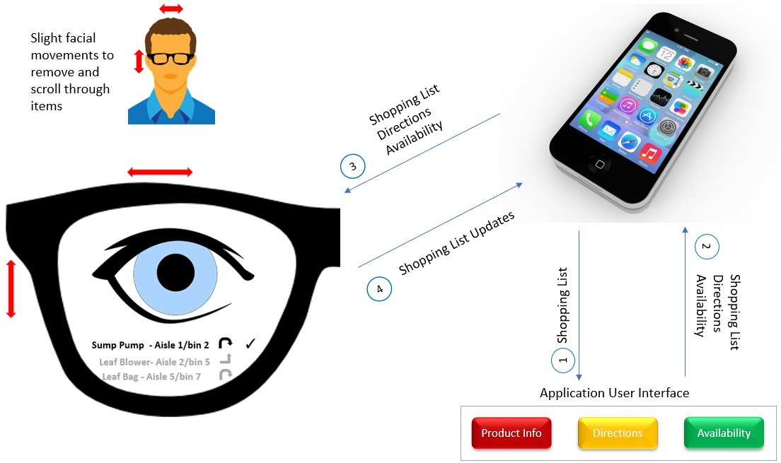

**Figure 1. The sketch of the smartphone and smart glasses integration design**

**Design Alternative 2 - Shopping App for Google/Intel Clarity Glasses**

The shopping app for the Google Glasses/Google Glass design ties back to the need-finding exercise by being a quick way to display to the user the directions to an item on the user’s shopping list. Instead of having to look around and locate a store team member to ask about the location of an item, which was noted in the surveys as being a time-consuming experience for the user, the user would be able to just look at the heads up display of the smart glasses in order to find the direction of the item they were looking for. Figure 1 above shows the display in the smart glasses interface for a user tracking a particular item. Appendix G describes further design of the smart glasses interface and functionality.

**Design Alternative 3 - Store Tablet**

This design alternative implements the ‘store tablet’ set of ideas our team developed in brainstorming in response to the store managers’ need for data privacy. If we develop a device that cannot be removed from the store, then data on item location will remain securely in the possession of the store owners. User will use their smartphone to create shopping lists via an App. Once at the store, users will check out a tablet and transfer shopping list from their smartphone onto the tablet. The tablet will parse the store’s location information and provide directions to each item. The tablet can be affixed to the customer’s shopping cart.

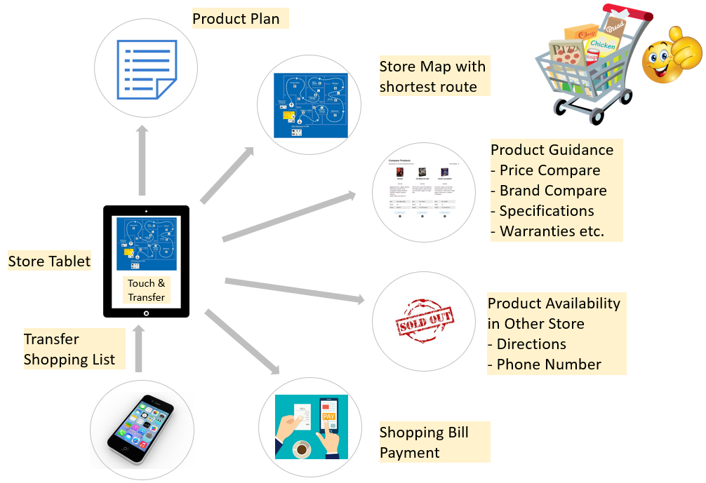

**Figure 2. The overview of the physical tablet design**

# Prototyping

## Prototype 1 - Shopping App for Google Glasses - Wireframe

## 

**Figure 3. The prototype interface of the smartphone and smart glasses integration design**

The Shopping App for Google Glasses will be available on IOS and Android OS.

1. **Store API**: Store API is the invisible part of this interface. It takes the shopping list from the cellphone app and processes the same based on the criteria e.g. shortest path to find items and sends out the shopping list and the directions to the cellphone. The API will also indicate if the item is available in the store or otherwise. In case if the item is not available in the store it will provide directions as to which branch of the store carries the same and provide branch details in orderly fashion based on the nearest location. The API will also indicate if the store is too busy or crowded. Other than that the API will also send details to the cell phone such as product specifications and product compare information if alternative products are available.

2. **Signup-Frame**: The signup will allow the user to create an user id and password as part of the signup process. Additionally, it will allow the user to set up payment profile that can be used to pay for the products purchased without having to wait in payment queue.

3. **Home-Frame**: Once the user has signed into the app, the interface displays the home screen. Home screen provides a list of active stores 5 at a time (usually last 5 shopping episodes) with a checkbox next to each of them in addition to a “repeat” button. The user can select a check box next to a shopping episode and click on the repeat button to recreate the shopping list. This will take user to the “Shopping list” screen where user can further update the list based on the requirements. The user can also select the check box next to the episode and click on the info button to display what was purchased during the shopping episode, what amount was paid against each of the products and what was the total payment etc. Furthermore the user can click “Create New Shopping List” that will allow the user to create a new shopping list and associate with a particular store.

4. **Shopping List**: The Shopping List screen allows the user to create a shopping list after the user has clicked on Home -> Create New Shopping List button. The user can click on the “+” sign to add an item and once the item is added the user can modify or remove the item by clicking “-“. There are 4 buttons on this screen e.g. “Save Shopping List” to save the shopping list, “Get Product & Store Info.” to send the shopping list to the store api and to receive the product info, availability and directions, “Send List to Google Glass” to send the information received from store api to “Google Glasses” and finally “Scan and Pay” button to scan and pay for the items purchased. The Shopping List screen will also display the store busy status, product specification and product compare information etc. Once the shopping is complete the store directions, aisle and bin information and critical product information will be self destroyed by the Shopping App, except the store receipt that will be available on the information screen. This will allow the app to maintain Store Owners/Managers privacy,

5. **Google Glasses:** Google Glasses will take the shopping list and directions from the Shopping App and display the same in the lower half of the glasses. The Google glasses will display top 3 items from the shopping list along with the aisle and bin details and directions to the next item. As the shopper finds the item it will check mark the item on the list and remove the same from the list. It will then put the next item on the top and the process continues. The Google glasses will also allow the user to remove the item from the list, put back the immediately deleted item on the list, allow the user to scroll up and down the shopping list. These glasses continuously provide the shopping status feedback to the Shopping app.

## Prototype 2

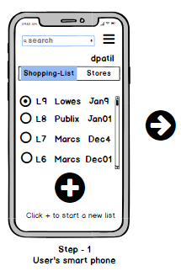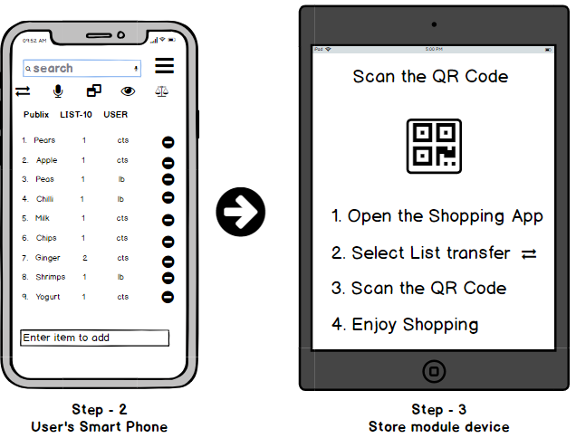

**Figure 4. Prototype-1 for synching list with store module**

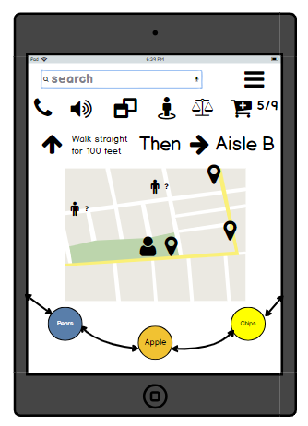

**Figure 5. Prototype for navigation on store module**

Our Prototype 2 is multi module app. It consist of two modules, one which is installed on user’s smartphone and other installed on the store’s tablet. This design was initiated to mitigate the issue of store owner’s reluctance to share the in-store navigational data to third parties like us. In this design, the store owner do not have to share the information with anyone as the navigation is displayed on store’s own devices

User will create the shopping list on the module which is installed on its smartphone and then transfer this shopping list to the store’s module using QR code process as shown in Figure-4. The in-store module will then provide all the needed navigation and functionality to the user.

The navigation is then provided by the in-store module as shown in figure-5. There are other intrinsic features in the in-store module where user can find out the location of nearest store employee for help. There is comparison tool feature which can be activated by clicking “weighing balance” icon. The module also provides aisle view by clicking “eye” icon. Module also has substitution recommendation feature which can be activated by “two pages” icon. Last but not least, users can also call the store customer service department directly from the in-store module.

# Evaluation Planning

## Prototype 1: Smartphone App and Google Glass Integration

The prototype mentioned above will be evaluated for creating a shopping list and finding items on the list with all appropriate feedbacks. Each individual user will be briefed with the background of the project and how it has evolved, leaving all the biases such as confirmation, observation, and other biases at bay. The interview conducted will be 100% scripted with a well-rounded discussion. The participants will be provided with the wireframe prototype and will be allowed to go through the same. In case of any questions, the same will be clarified immediately due to the synchronous nature of the setup.

## Qualitative Evaluation using Interviews - Question Planning

1. Do you know how to create a shopping list with the application?
2. Can you figure out how to add items within the app?
3. Do you understand how to use Google Glass with this smartphone app?
4. Can you understand the instructions being displayed on the Google Glass?
5. Can you figure out how to move to the next item after finding your selected item?
6. What do you like about this interface?
7. What do you dislike about this interface?
8. Can you figure out how to navigate and find items with this app?

## Predictive Evaluation using Cognitive Walkthrough

The cognitive walkthrough for the smartphone app and Google Glass integration will be performed as part of this prototype evaluation. The goal for this app is to ensure that the user can navigate through the items on their shopping list successfully find items and ultimately complete their shopping trip using the aspects of the smartphone/Google Glass prototype. The walkthrough will assume that the user has already signed up for the application and has provided all pre-requisite information such as their shopping list, preferences, etc. and will assume that the user has walked into the store ready to sync up with the clarity glasses. Figure 3 referenced above in the prototypes section will be used as the basis for this cognitive walkthrough.

## Prototype 2: Store Tablet

The prototype mentioned above will be evaluated for the shopper’s ability to load their shopping list onto the store table and find items using the tablet navigation interface. Each individual user will be briefed with the background of the project and how it has been evolved leaving all the biases such as confirmation and observation etc. at bay. The interview conducted will be 100% scripted with a well-rounded discussion. The participants will be provided with the wireframe prototype and will be allowed to go through the same. In case of any questions, the same will be clarified immediately due to the synchronous nature of the setup.

## Interviews

1. Do you know where to go to find the store’s shopping information tablet?
2. Do you know how to sync your app’s shopping list with the store’s tablet?
3. Can you tell me how to find the store employee’s location for help?
4. Can you tell me how to use compare items feature?
5. Can you tell me what do you understand by aisle view and how to use Aisle view feature?
6. Can you find out how many items have you already shopped from your list?
7. Can you tell me how to call store’s customer service department?
8. Can you tell me what the different colors on the Ferris wheel means?
9. Can you tell me which item are you shopping currently?
10. What do you like about this interface?
11. What do you dislike about this interface?
12. Do you know how to navigate the store with the store’s tablet?

## Cognitive Walkthrough

The cognitive walkthrough for the store tablet will be used as an evaluation for this interface. The goal for this application is for the user to be able to find the shortest path to the item in their list using an application synced up to a tablet that has already been placed in the store and is available for shoppers to use. The walkthrough will assume that the user has already signed up for the service and has walked into the store ready to sync up with the store’s tablet. Figure 4 and figure 5 above in the prototypes section will be used as the basis for this cognitive walkthrough.

# Evaluation Execution

## Prototype 1: Smartphone App and Google Glass Integration

## Qualitative Evaluation - Interviews

Total of 4 participants were recruited for this evaluation. All the interviews were done independent of each other. Participants were first shown the prototypes-1 and asked them to go through them. Once they were done, they were asked the pre-scripted questions. We all noted their responses and some of these responses are inserted in the appendixes. Some interviews were done in person and some were done on the phone. For those which were done on the phone, we sent the prototype electronically to them. If we have to do it again, everyone felt that all the interviews should be done in person so that we could understand the respondent’s responses clearly. While you are interviewing the person on phone there are limitations in capturing the overall responses and having counter and follow-up questions.

Summary of the Interview:

1. 3 of the respondents felt they kind of knew how to use google glass. One of the respondents did not really understand the technology.
2. Well most of the respondents felts it was novel idea and it could make their hands free, one of them felt it was great because it shows the shortest path
3. Since none of the respondents have really used google glass, everyone was either not sure how it is going to be used. One of the respondents thought the prototype was confusing without a background info.
4. Most of the users were not sure how to add the item to the list
5. Most of the users were comfortable how they would move to the next items
6. Most of the users were able to understand the navigational directions on the google glass but few felt that the direction could be little more detailed.
7. None of the respondents were able to understand how to get the aisle view on this prototype
8. Most of the respondents were able to understand the instructions.
9. This was mixed response, some felt they could copy old shopping list but were not sure how they could create a new one
10. Most of them were not sure how to add items using barcode scanner. This could have been a slippage in our design.

**Analysis**: Most of the respondents felt the google glass design was novel and would help them shop better as they do not have to hold phone in their hand. However, for the respondents who are not tech savvy, it was not very clear how exactly they can use the functionally. Most of the design was easy to understand except few design features which were missing in the design. It was actually a slippage on our part. Feature like aisle view was included in the prototype-2 but was not included in the prototype-1 hence respondents were not able to discover this feature. Most of the respondents were able to understand the navigational direction provided but felt that it would help them if little more detail could be added to these directions.

**Changes suggestion:** Based on the evaluation, we definitely need to add the aisle view and barcode scanner features which somehow we missed to add in to the prototype. Also, as per user’s suggestion, we think we should add more detail to the navigational direction to the google glass screen. As few users comments were that without background info, it would have been difficult to understand few features, we understand that there is little learning curve in using this interface and we could display some hints for new users.

## Predictive Evaluation - Cognitive Walkthrough

**Assumption**: The user creates a new shopping list without selecting the active store from the list and using the previously created list.

**Goal**: Navigate the app to add a shopping list and find information on the items on the list in the store.

**Plan**: The user logs into the application by entering their username and password. After logging in, the homepage is loaded on the mobile app. On the home page, the user immediately sees a list of their stores that are currently active such as Lowe’s, Shoprite, etc. None of these stores are selected yet, so the user will tap on a shop name in the list. Once the user has tapped on a store name, a green check mark will appear to let the user know that the particular store has been selected. From there, the user can click on the list view (bottom bar - middle hamburger button) in order to bring up the shopping list for their selected store. Through these two interfaces in the app, improved **discoverability** is a key feature for seamless navigation and informing the user of what action they are currently taking.

The home page specifies the action that the user should take to guide the user on what to do within the interface. For example, User can click “Create New Shopping List” button to create a new shopping list for a specific store. After clicking this button the app takes the user to Shopping List screen where it displays a text box to enter the name of the store followed by a “+” sign to add items to the list. However, user can also select a store from the active store list and click on a repeat button. This will take the user to the Shopping List screen and display the previously created list. User can now add (“+”) or remove (“-”) items to modify the list.

**Actions performed**: User clicks on the “Create New Shopping List” button and this takes user to the Shopping List screen that displays an empty text box (labeled “Store Name”) that allows the user to enter the name of the store. The screen also displays “+” sign that allows the user to add items to the list. This will be a positive aspect of the design of the interface by catering to both novice users and expert users of the application. Clicking the plus sign will add an empty text box to the list and the user is able to immediately start typing their item - this is an example of immediate **feedback** within the application. After entering in all items to the shopping list, the user is then able to save the shopping list and is informed that the list has been saved. **Flexibility** is achieved here because the user sees a minus sign next to the item that they have entered. This is important for flexibility because it allows the user to remove an erroneous entry and re-add what they were meaning to add.

**Perception**: The user is able to add or edit items in the shopping list and save the shopping list, and is able to perceive the items on the list and the other options within the shopping list interface.

**Interpretation**: Once the user is happy with the items on the shopping list and has saved it, they are able to bring up the product and store information to interpret the results of the items that they have entered in their shopping list. Another option that the user can interpret is the option to send the list to their smart glasses in order to get directions for the item in the store.

**Comparison**: The user’s goal of navigating the application to add their shopping list and get item information was achieved after performing the above actions.

**Conclusion**: The prototype analyzed here has provided the appropriate discoverability, feedback, flexibility, learnability, and recognizes that the gulf of execution needs to be low in order for a wide-range of users to successfully navigate the app.

## Prototype 2: Store Tablet

## Qualitative Evaluation - Interviews

Even for this prototype evaluation total of 4 participants were recruited. All the interviews were done independent of each other. Similar process was repeated as described for the interview section for the prototype-1.

**Summary of the Interview:**

1. None of the respondents were sure what was the question all about. It was confusing for them
2. All 4 of the respondents were very clear what to do to sync the two devices
3. All 4 of the respondents were very clear on how to find the relative location of the store employee.
4. 2 of them were able to understand the task of comparing, 1 of them guessed it but was not sure and 1 of them was not sure at all.
5. Most of them guessed the aisle view feature thinking it would be similar to street view
6. All of the respondents were able to tell the shopping status
7. All of the respondents were able to correctly tell how to call customer service
8. 3 of them were able to tell correctly the color coding and what they meant. 1 was not sure
9. All of them were able to guess this task
10. Most of them felt once they know the features and their corresponding icons, the interface can be very simple
11. 3 of the users felt that in-store module feature was little uncomfortable. They also asked what happens if the store device is unavailable
12. All of the respondents were able to follow the navigational direction

**Analysis**: All the respondents felt comfortable while going through the prototype. Since some of the features and its icons are little new, there is some learning curve for them to map the icons to the feature. Mapping of compare to “balance icon” was new to them. However, once they are able to map those two things, it will be very easy for them to use. Majority of the users felt the extra task of going to store and syncing the shopping list to the store device little uncomfortable. They felt if the store device are not sufficient, they would waste time waiting for those devices to be available.

**Changes suggestion:** There are few changes which are quite obvious after the evaluation. Since the **mapping** between the icons and features are new, we should implement a feature where we display hints for new users to help them learn these new mappings. Also, we should have some information or help for user to locate the store device comfortably.

## Predictive Evaluation - Cognitive Walkthrough

**Goal:** Navigate the app to sync their smartphone app with a store’s tablet, and use the tablet to find directions to items in the store.

**Plan:** The user logs into the application on their smartphone by entering in their username and password. After logging in, the homepage is presented with an empty or already filled out shopping list based on if the user has used the application before. If the user wishes to add items to the shopping list, then they have the **flexibility** to add items to the shopping list in different ways either through the keyboard, barcode scanner or the microphone. Once the items are added, the user can then enter the store and sync their phone with the portable tablet in the grocery store.

**Actions performed:** Here **affordances** are realized because the store’s tablet will request that the user first scan the QR code displayed on their screen in order to proceed with syncing the device with the user’s smartphone. This is an affordance due to the design of the tablet in that it will not proceed without having a smartphone to sync with.

**Perception:** After syncing with the store tablet, the user is then able to view a layout of the store on the store tablet. The user is able to **perceive** the location of the items based on the directions given and the map shown.

**Interpretation:** While shopping, the lower half of the interface shows the items on the shopping list relative to the user’s location. The item that the user is closest to will show up in the middle while items that are further away will show up on the sides in a different color.

**Comparison:** The user’s goal of syncing their smartphone with the store tablet and navigating the store with the table was achieved during this walkthrough.

**Conclusion:** The prototype analyzed here included flexibility, affordances, discovery, and perceptions to lower the gulf of execution for users to successfully use this interface.

# Conclusion

**Summary**:

In this iteration of the design life cycle, we added a new class of the user’s namely professional shoppers and we also focussed more on the store owners as they are also important stakeholders. I think both these points were not covered in the first iteration of the design life cycle done by Dajiba Patil. The findings of our needfinding methods gave a **different model** of a problem to us as most of the store owners were reluctant or had concern in sharing the store specific informations(in-store navigation and items information) to the third parties. The findings of the our needfinding methods also gave a clear message to us that professional shoppers are **NOT users** of our App. We also understood that our main users are normal shoppers and they will benefit a lot with application such as ours. As a result, our design has **evolved** considerably from the original design while maintaining look feel of the original design. We have now built secure web-api and in-store device modules to mitigate the issue of store owners privacy concern of their data. We have also incorporated google glass technology to our interfaces in line with principle of **ease and comfort**.

**Next Steps:**

We would definitely need next design life cycle to probe more on the store owner user group. We would need to perform detailed interview with them to understand their mindset and mental models. The next steps of the project would be to start building a higher fidelity and somewhat functional prototype of our Google Glass and smartphone integration application. From there, we would begin limited trials of each iteration of the prototype using focus groups and small samples of each user base interacting with the application and the smart glasses device. Improvements to the application would be made from feedback gathered from the focus group testing.

**New questions about the User:**

We still have a few questions about the primary and secondary users. We still need to understand if our primary users will accept the idea of multi module application as proposed by our prototype-2. We also need to understand if our primary users like to use of google glass for shopping and how comfortable they are with the new technology. We also have lot to explore from our secondary users like store owner and managers. They are the main players who decide how the store specific navigational data and item information are shared and displayed on our apps. One store owner had a big concern with the original design as he felt his competitor can use this app to spy on his business. However, he was also supportive of any app development if this issue can be resolved. We have few ideas which we think can mitigate this issue and we feel we should focus more needfinding time on exploring this secondary user in our next design cycle.

**Next step on prototype and evaluation:**

Next steps of the project would be to start building a higher **fidelity** and somewhat **functional** prototype of our Google Glass and smartphone integration application. Since these prototypes would be high fidelity and more functional, we would be more interested in **empirical** evaluation so that we could evaluate **performance** of our app by measuring **time** and **correctness** of the data shown. We could also start testing our app for Reliability and Validity. We would also need summative kind of evaluation so that we could conclusively say this prototype is better than other. We could also start doing field testing our app in some of the stores. We would still perform some kind of Qualitative and Predictive evaluation(Cognitive walkthrough) as our prototype is still evolving and there would be few new ideas and features that will be added which we feel would need these kind of evaluation.

# 

# References

# Dr. David Joyner, Human Computer Interaction course video series, referred from 11/24/2018 to 12/09/2018.

# Margaret Rouse, <https://internetofthingsagenda.techtarget.com/definition/Google-Glass> , July 2013

# Wireframe Tool:<https://balsamiq.cloud/>

# Instacart:<https://www.instacart.com/>

# Appendices

## Appendix A: Needfinding 1 Survey Questions

The following questions pertain to your shopping experience at grocery stores (Kroger, Publix), wholesale clubs (Costco, Sam’s), department stores (Walmart, Target), and hardware stores (Home Depot, Lowes). Please describe your experiences at these stores.

1. How often do you plan to buy new items that you haven’t purchased before?
   1. Always
   2. Often
   3. Sometimes
   4. Rarely
   5. Never
2. On average how much time do you spend searching for specific items you’re unable to locate? (in minutes)  
   ______
3. Describe your agreement with the following statement: In general, I am consistently satisfied with my current shopping experience.
   1. Strongly Agree
   2. Agree
   3. Neither
   4. Disagree
   5. Strongly Disagree
4. Is your preferred in-store shopping method browsing all of the aisles or going straight to the items you need?
   1. Browsing all of the aisles
   2. Going straight to the necessary items
   3. A mixture of both
5. What things would enhance your shopping experience?
   1. Shopping List
   2. In-Store Navigation/Mapping
   3. Electronic Product Locator
   4. Other
6. If you selected Other on the previous question, please describe it here  
   ________________________
7. On a scale from 1 to 5, how often do you have your personal smartphone with you while shopping?
   1. Always
   2. Often
   3. Sometimes
   4. Rarely
   5. Never
8. Do you ever utilize existing shopping cart programs such as Kroger's clicklist?
   1. Yes
   2. No
9. Do you use shopping services like instacart or store's shopping services
   1. Yes
   2. No
10. If you answered Yes to previous question, what is the main reason you use these services
    1. Busy schedule
    2. Shopping difficulties
    3. Other
11. If you answered “Other” to the previous question, please explain:   
     ____________
12. How often do you use shopping lists?
    1. Always
    2. Often
    3. Sometimes
    4. Rarely
    5. Never
13. If you use a shopping list, approximately what proportion of the time are you the person creating the shopping list for your shopping episode (vs someone else)? (in %)  
    ________
14. Describe your agreement with the following statement: It is helpful to plan the path you will take to collect each item on your shopping list.
    1. Strongly Agree
    2. Agree
    3. Neither
    4. Disagree
    5. Strongly Disagree
15. How frequently do you seek help to decide on a product when presented with number of options?
    1. Always
    2. Often
    3. Sometimes
    4. Rarely
    5. Never
16. Describe your agreement with the following statement: When I ask for help locating an item that is on my shopping list, I am very satisfied with the help I receive.
    1. Strongly Agree
    2. Agree
    3. Neither
    4. Disagree
    5. Strongly Disagree

## Appendix B: Interview with Bottle King Store Owner

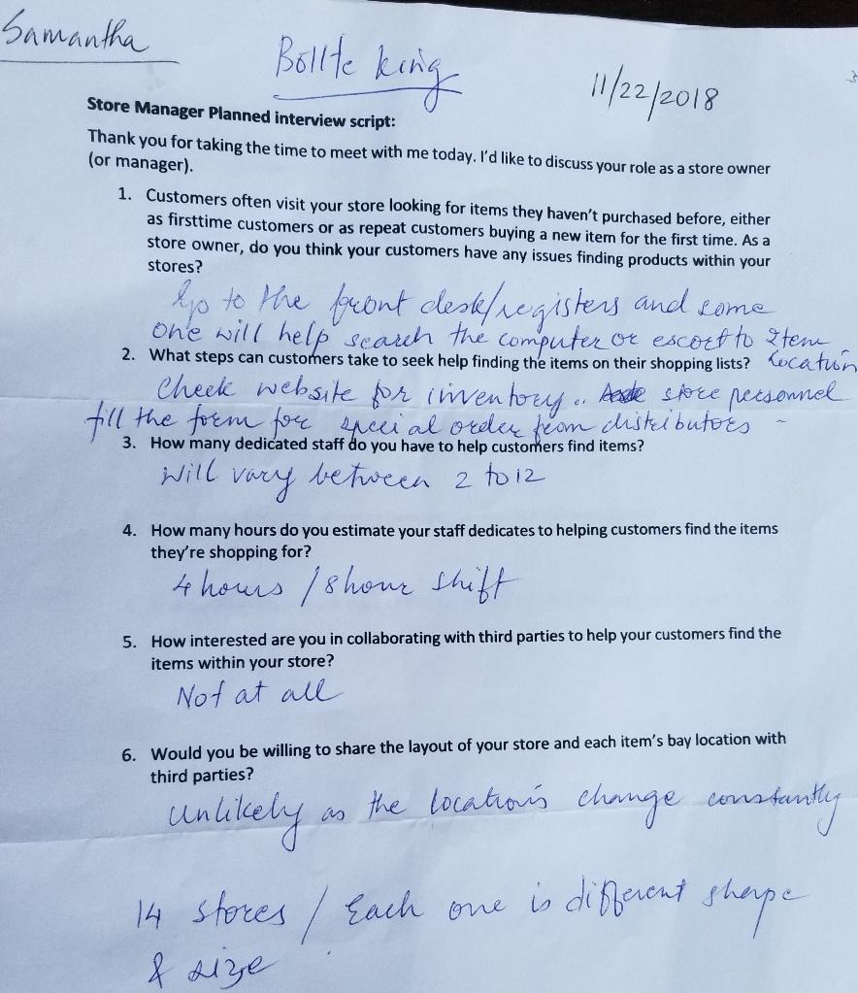

## Appendix C: Interview with Lowes Store Owner

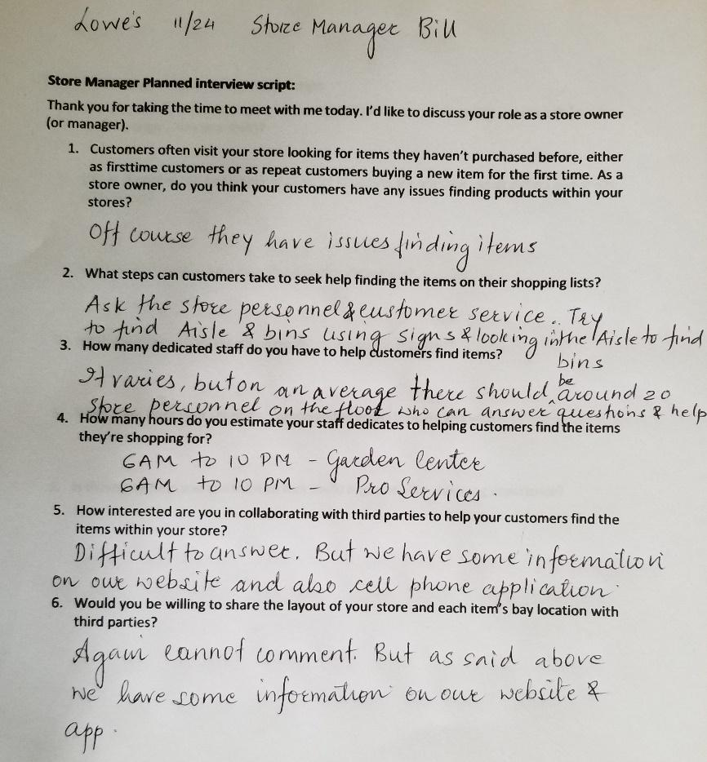

## Appendix D: Interview with Lowes Store Owner

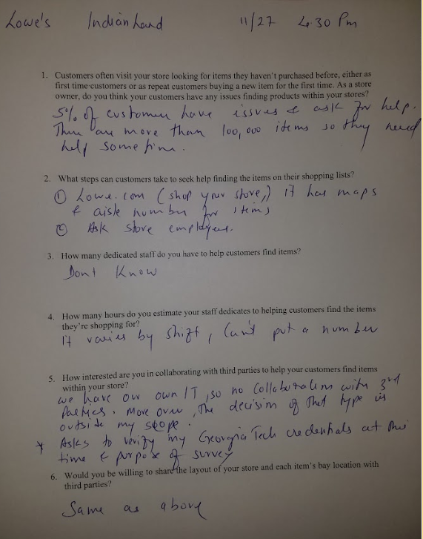

## Appendix E: Interview with Instacart shopper inside Publix

Thank you for taking the time to meet with me today. I’d like to discuss your role as a professional shopper.

1. Can you briefly walk through a recent typical professional shopping experience (maybe walk through a day or a shift)?
   * First, grab a cart and the customer’s bag (each customer is given a brown bag with their name and a barcode). The app lists the customer’s shopping list in order of pickup location within the store. Traverse the store and pick up the relevant items in list order. Once the bag has been filled, place it on the filled bags shelf either within or outside of the freezer. A separate delivery driver will pick up the bags for delivery.
2. When shopping for customers instead of shopping for yourself, what differs about the experience?
   * No difference - as an experienced shopper I am able to locate basically any item in the store.
3. What is your main focus when shopping for customers?

* Keep refunds down by offering replacements. Keep speed up (create shopping bags as quickly as possible).

1. How many customers are you typically shopping for at a time?
   * 1 or two customers at a time.
2. What tools does your shopping company (Instacart) provide you with?

* The Instacart app shows shopping items in order along with customer notes and allows the shopper to communicate with the customer via phone or text

1. Is there anything you can think of that could improve your shopping experience?

* Shopping without other customers in the store!   
  Sometimes the app doesn’t list locations of items correctly and you’ll need to manually locate an item.

1. What do you do if a particular item is not available in store?

* Check the back of the store (the warehouse). If the item is truly out of stock, offer to find a replacement item for customers.

1. How frequently do you need to ask for help in locating an item?
   * Never. With experience we know where all items are.

## Appendix F: Interview with Anthon, a manager at my local Publix

Thank you for taking the time to meet with me today. I’d like to discuss your role as a store owner (or manager).

1. Customers often visit your store looking for items they haven’t purchased before, either as first time customers or as repeat customers buying a new item for the first time. As a store owner, do you think your customers have any issues finding products within your stores?
   * Yes, because stores are often differently laid out
2. What steps can customers take to seek help finding the items on their shopping lists?
   * There are always associates nearby that customers can ask for assistance.
3. How many dedicated staff do you have to help customers find items?

* Over 20 at any given time

1. How many hours do you estimate your staff is dedicated to helping customers find the items they’re shopping for?
   * 3 hours throughout the day
2. How interested are you in collaborating with third parties to help your customers find items within your store?
   * Already partnered with instacart and location apps - check the Publix website
3. Would you be willing to share the layout of your store and each item’s bay location with third parties?

* Not sure if we do so currently, but we have a team focused on this data internally. Maybe Publix corporate could help answer this question.

## Appendix G: Interview with Shipt representative at Publix

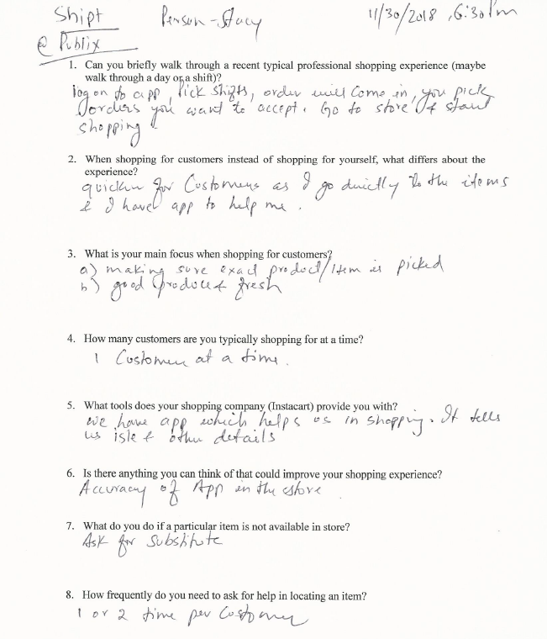

## Appendix G: Glasses Prototype

This idea is inspired by using the shopping list right in the line of sight while keeping hands free to perform other tasks such as picking up items, placing them in the cart, scanning the items purchased and paying them as the user shops. This idea is improvised version of the combination of cellphone and store api, where it leverages the cellphone to collect the shopping directions from the store api and transfer the same to the Google glasses. Once the shopping list and the directions are transferred to the Google glasses, they display an ordered shopping list with store directions based on the shortest path to collect these items in the lower half of the glasses. In addition to providing the shopping list and directions Google glasses help to control the list e.g. once the user finds and picks up the item on the list, it “checkmarks” the item and removes the item from the list while moving the item below to the top and repeating the process. The Google glasses also allow the user to control the list by gestural movements e.g. by focusing on the item on the list and turning the head slightly to the left or right will either remove the item from the list or put back the immediate deleted item on the list. The user while focusing on the shopping list can scroll through the shopping list up or down by slightly moving head up or down respectively.

The key interface components and its functionality is mentioned below.

**Store API:** Store API accepts the shopping list from the subscriber e.g. cellphone smart app and processes the same based on the criteria such as shortest path or customized shopping list order and throws back the shopping list and the directions to the cellphone. The API will also indicate if the item is available in store or otherwise. In case if the item is not available in the store it will provide directions as to which branch carry the same and provide branch details in orderly fashion based on the nearest distance.

**Shopping App:** The second key component of the interface is the Shopping app that can be downloaded and installed on the cellphone. This application will allow the user to create a shopping list. The user can send this shopping list via shopping app to the store API to process and provide e.g. shortest path to find and pick the items from the shopping list. The Shopping app sits at the center of this interface and co-ordinates with the store API and the Google glasses. It takes the product information and directions from the store API and sends it to the Google glasses. The Google glasses also send back information to the shopping app about the product/items found, not found and removed etc. The shopping app then provides a summary of the shopping experience to the shopper.

**Google Glasses:** Google Glasses will take the shopping list and directions from the Shopping App and display the same in the lower half of the glasses. The Google glasses will display top n items from the shopping list and as the shopper finds the items it will take that items from the list and put the next item on the top along with the directions. The clarity glasses will also allow the user to remove the item from the list, put back the immediately deleted item on the list, allow shopper to scroll up and down the shopping list and check mark the items found and picked while shopping.

## Appendix I: Prototype Survey Full Responses

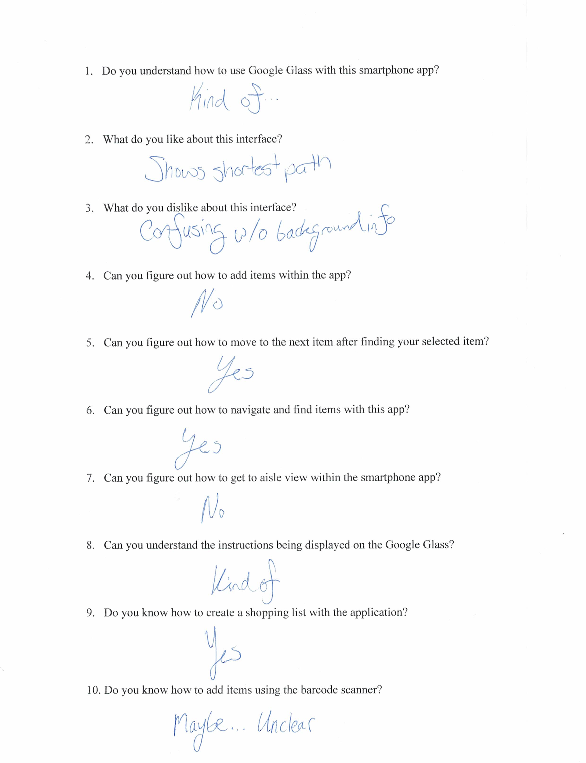

## Appendix J: Prototype-2 Interview response

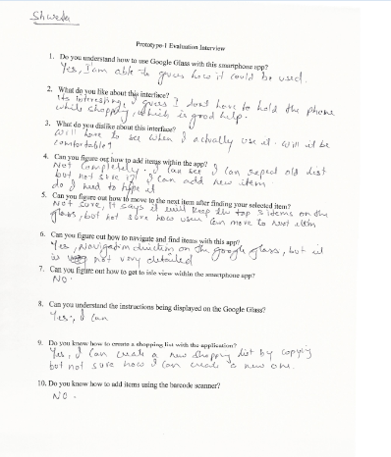

## Appendix K: Prototype-2 Interview response

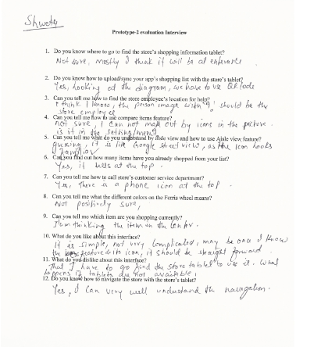

## Appendix L: Prototype-2 Interview response

